Using Safari Montage
With a Substitute Teacher

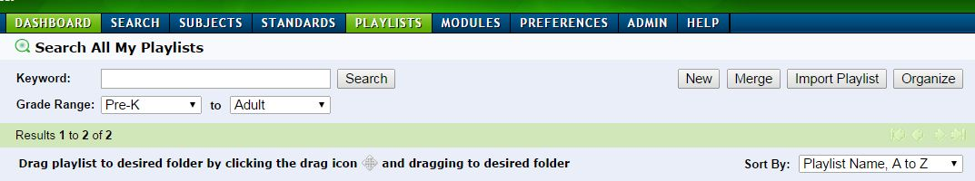
To use Safari Montage videos with a Substitute Teacher
Login to Safari Montage
Choose Playlist from the Dashboard
Click on New
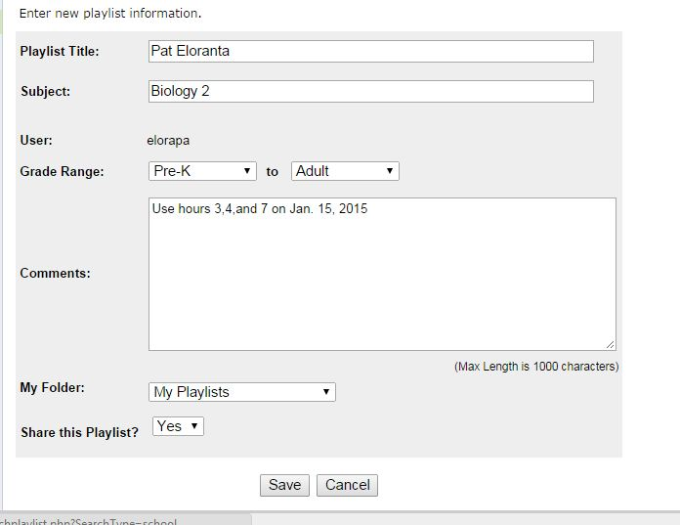
Name your Playlist with your name
Enter the class name in Subject
Enter details (classes /hours/directions) in the Comments section
Choose Share this playlist
Save

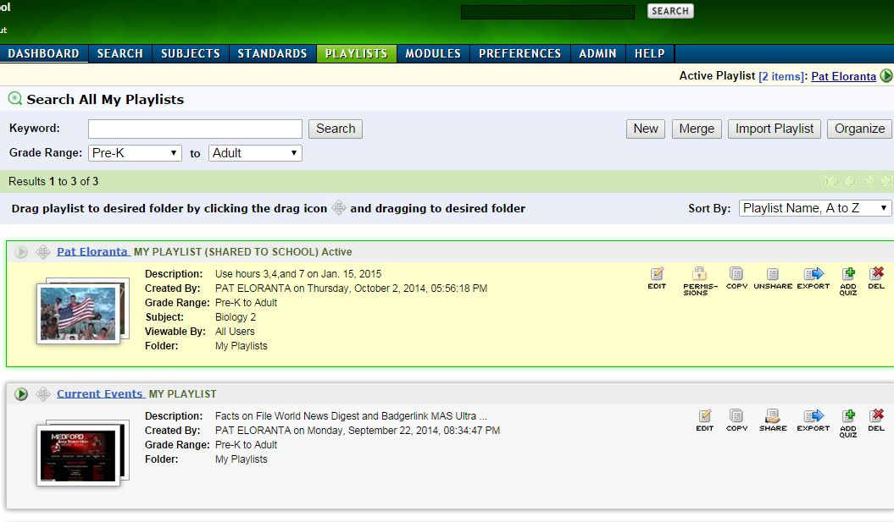
Verify that you are in the correct playlist before locating any videos. Check the upper right hand corner for the active playlist. Return to my playlists to re-select if needed.
Locate your videos and add to the playlist

Leave page 2 for your sub

Using Safari Montage

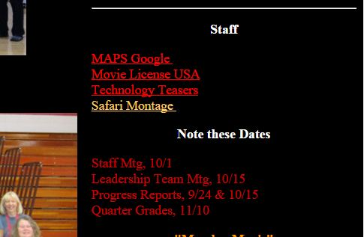
Login to the network
Open the internet to the MASH homepage
Click on the Safari Montage link located on the bottom right of the page
Login to Safari Montage:
Username: user
Password: netware

Click the Playlist button and enter the teacher’s name
There you will find the videos with notes about playing them in the description area
Click on the green play button to start the video(s)

Call the library staff if you have questions, or need help.

